Radius Arm Bushing Remove & Replace Incorrectly 11/2/2016……….………….230.00
Radius Arm bushing Kit K8295 Incorrect To 10/80……………………………………… 62.97
Radius Arm Bushing Kit K8359 Correct From 11/80 Truck Date 6/81
Supp, Cleaning Mat, Haz Mat…………………………………………………………………………….7.00
299.97
Tax…………………………………………………………………………………………………………………..11.59
Total………………………………………………………………………………………………………………311.56

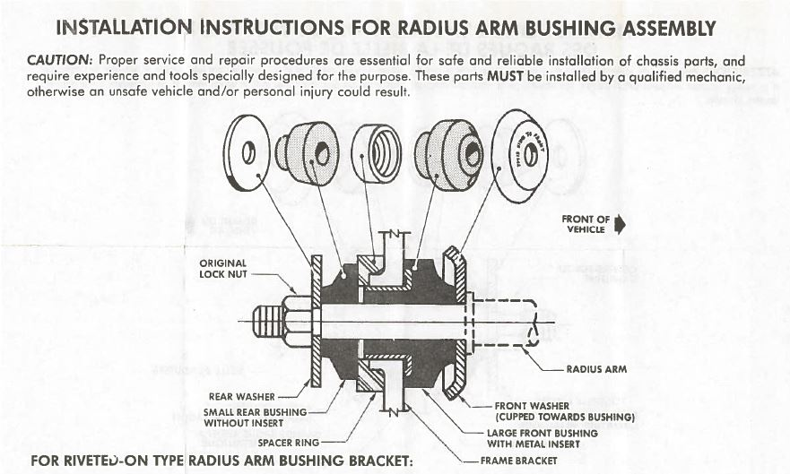
As Installed By Preferred Auto Repair I spoke with Sal about this issue on 1/11/2021 and was told it was not under warranty and could be repaired for $395. Mileage 40197 88298 48101
